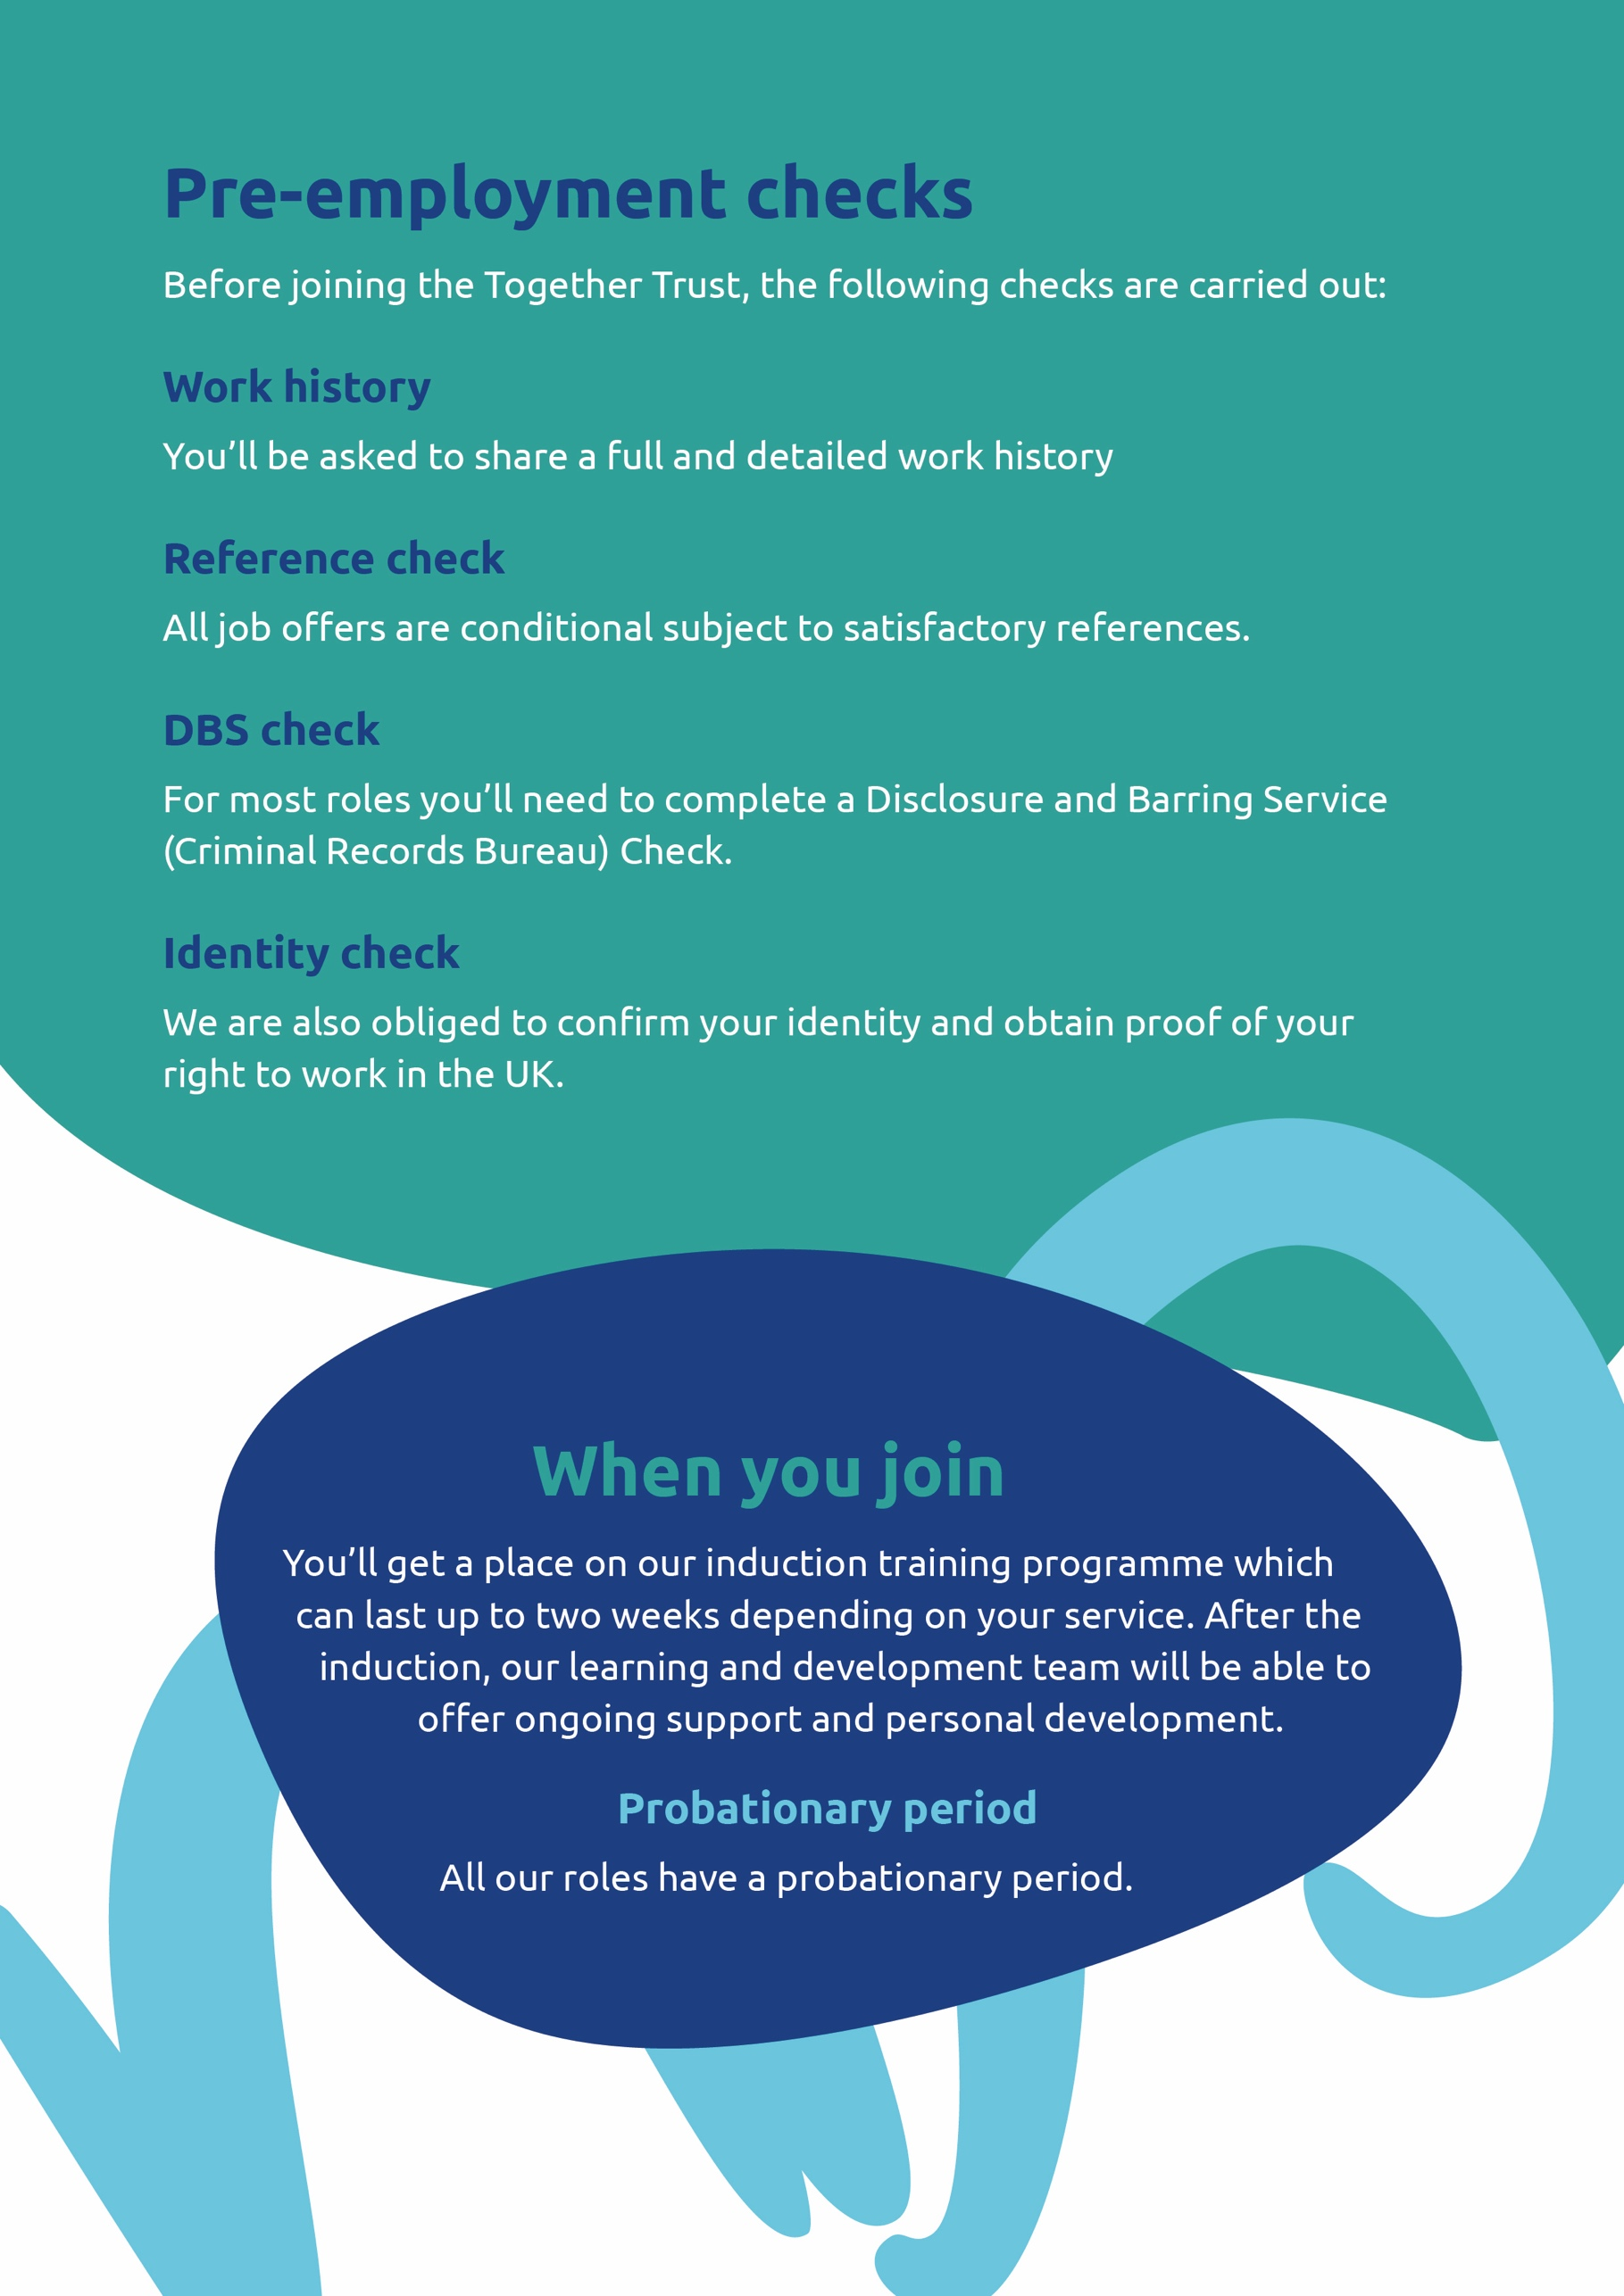
Job description

Job title
Senior Community Support Worker

Hours
37.5 hours per week
Hours worked flexibly across the week, including evenings, weekends and public holidays according to the needs to the service.
If working in supported tenancies, you may be required to complete sleep in duties as part of your role, for which an additional payment will be paid when undertaken.

Contract
Permanent

Role profile and grade
PCS25 - Grade 2, Point 4 rising to Point 6

Salary
Starting salary - £29,108 per year (£14.93) with biennial increments

Additional Payments
Enhanced pay for weekend shifts - 25% added to your hourly rate of pay. (£18.66ph) – you will be expected to work 1 in 2 Saturdays with a replacement day off during the week.

Location
Newbridge Centre, Stockport

Reports to
Team Leader/Service Manager

Type of DBS required
Full Enhanced (We will apply for this on your behalf.)

The individuals that use our services have a variety of complex needs that may include learning difficulties, autism spectrum conditions, mobility (ASC), communication, health and social care needs. We support each person to maintain their independence and to achieve positive outcomes in line with their own needs and wishes.

Job purpose

The Senior Community Support Worker role is integral to ensuring that all services are effective at the point of delivery. Operating within the current legislative framework and adhering to the Trust’s Policies and Procedures.
You will help ensure the individuals who use the service receive high-quality, person-centred support that meets their physical, health, emotional and social needs. Assisting in the development and maintenance of their support plans as required and developing positive and engaging interactions with individuals that use our service, their families and all other stakeholders involved.
You will provide line management to a small staff support team, developing their capability through demonstrating the right values and behaviours, mentoring staff and supporting their ongoing development.
Safeguarding vulnerable children and adults is a priority for all employees.
NB. The following job description is not exhaustive and there may be times you will be required to undertake other duties in order to meet the needs of the people supported under direction from the Team Leader or Service Manager.

Key responsibilities
Support Duties

- Provide a caring, safe, secure and accepting environment/service that meets the physical, health, social needs and rights of the people supported and their families. This will include ensuring that cultural and religious needs are respected, promoted, facilitated and met.
- Promoting independence of the people supported whilst preparing, assisting and enabling them to fulfil the aims of their Person-Centred Plan. Fostering self-awareness, personal growth and voice for decision making and lifestyle choices.
- Key tasks will include undertaking a range of duties that facilitate an individual’s safety and well-being. This will extend to providing personal assistance, personal care, and the administration of medication in line with the Trust policy and procedure documents
- Work pro-actively with the people supported whose behaviour may present as challenging to the service and others around them in line with the Trust Behaviour Management policies.
- Provide telephone support to staff and service users and their families.
- Provide signposting to advocacy and other community-based services for the people supported or their families if required.
- Under the guidance of the Team Leader, the Senior Community Support Worker will contribute to any initial assessments, support needs planning and risk assessments of the people who use our service.
- Ensure that all matters regarding safeguarding or staff concerns are escalated using the appropriate channels.
- Carry out general administrative duties, housing management tasks and services as required.

Line Management Duties

- Leading and allocating staff responsibilities within the service under the direction of the Team Leader.
- Provide 1:1 staff supervision to community support workers, including observation of practice and medication competency.
- Monitor that all support delivered is compliant with the Person-Centred Plan and outcomes agreed for the person supported so as to maximise their full potential.
- Assist the Team Leader in the creation of service rotas, ensuring that the staffing requirements are in in place to meet the needs of an individual’s support plan. Addressing any gaps in service provision in a timely and effective manner.

- Assist in the creation of accurate, up to date records of support, both planned and undertaken with individuals
- Develop and maintain a good level of awareness of safeguarding and protection issues, and raise any concerns regarding the people supported with the Team Leader or Service Manager immediately
- Oversee and monitor that all financial transactions are undertaken in line with the Trust Policy and procedure documents regarding supporting people to manage their own money
- Ensure that all quality assurance tasks around support, medication, finance etc. are completed within the appropriate timescales, escalating any immediate concerns to the Team Leader or Service Manager.

General Duties

- Successfully complete an appropriate Induction programme and to fulfil the Senior Community Support Worker accountabilities to a standard complying with the National Occupational Standards and CQC regulations for the post.
- Undertake training to maintain/develop your professional skills and practice in line with Together Trust Policies and Procedures and compliance with CQC Regulations. This will extend to being a coach or mentor to community support workers to ensure service continuity.
- Work closely with the service/s management team and with relevant agencies with due, regard to the views of service user, family and significant others. This will extend to notifying/update the Team Leader on a regular basis
- Always follow the Trust’s health and safety guidelines.

Person specification
You will need demonstrate the extent that you have the necessary requirements for this role. Please use examples in your application how you match the criteria in the person specification and your experience of the responsibilities outlined for the role.
 | Essential | Desirable
Education, qualifications and training | Basic literacy & numeracy skills.  NVQ 3 in care or equivalent CQF. | Makaton.  Emergency First Aid.
Experience and skills | Ability to undertake the full range of tasks, in a well-planned way that respects & values the service users as individuals.  Considerable Experience of working with people with disabilities/ Autism Spectrum Conditions and an awareness of their rights and needs.  Experience of working in community-based projects/activities for individuals.  Experience of working with families.  Experience of managing difficult and challenging situations whilst maintaining high standards of care and support.  Experience of implementing behaviour support plans and risk assessments.  Flexibility to respond to the needs of the project in the community.  Good communication and interpersonal skills-written and verbal.  Good organisational /time management skills and the ability to monitor activities.  Basic IT skills.  Ability and resilience to work with behaviour that may be perceived as challenging in a caring and consistent manner, ensuring the maintenance of appropriate boundaries for behaviour.  Ability to work individually on shift using your own initiative and as part of a team, maintaining & encouraging, open and honest communication.  Experience of supporting and coaching staff and nurturing team development | Experience of working with or within statutory voluntary agencies within community settings.  Experience of working and planning transitions with individuals and families.  Experience of supervising and mentoring staff.  Experience of writing and implementing Behaviour support plans and risk assessments.  Implementing plans devised by multi-disciplinary teams to meeting clinical, physical and emotional needs.  Assist with risk assessments within the home and community settings.  Knowledge of the issues that Tenants with disabilities may deal with on a day-to-day basis.  Ability to plan and manage staff rota’s.  Proficient in Microsoft packages.  Experience of creating proactive behaviour support plans.  A sound knowledge of person-centred approaches and tools.  Experience of devising and implementing staff development plans.
Knowledge and understanding | Knowledge of the issues affecting disabled people.  Knowledge of the Social Model of Disability and person-centred planning. | Knowledge of the Domiciliary Minimum Standards, CQC/ LA Inspection process and Supported Tenancy Model.
Other | Commitment to continuing personal and professional development.  A full driving licence held for twelve months or more.  An ability to work effectively within a team and provide guidance and direction in a way that leads to positive outcomes. | Attend Training to development oneself.

Applications are welcome from all regardless of age, disability, marriage or civil partnership, pregnancy or maternity, religion or belief, race, sex, sexual orientation, trans status or socio-economic background. We are committed to making reasonable adjustments for disabled people. We positively encourage applications from those with lived experience.

